Spectre du soleil

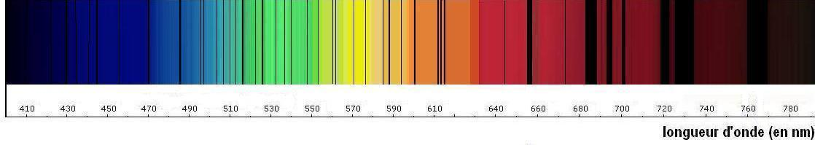

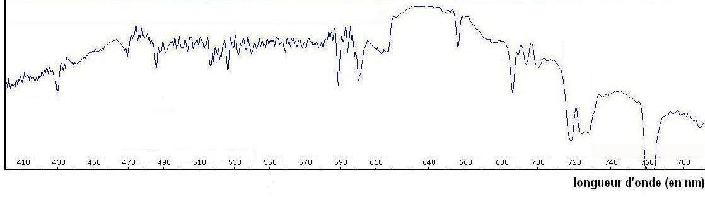
Spectre du soleil

